電通二乙微處理器實驗 實驗結報

實驗名稱 | Lab01
組別 | 8 | 組員 | 陳冠宇03050052 / 沈揚智03051030

- 實驗目的
測試 Arduino IDE 與 Arduino UNO 之連接
測試 Arduino UNO 硬體是否正常
觀察 Arduino UNO 之輸出
學習如何將 Arduino UNO 外接麵包板電路

- 實驗步驟
啓動 Arduino IDE, 載入 Blink 程式碼
外接麵包板電路
修改程式，將 LED 輸出改為 Pin 9
編譯程式並執行, 用示波器量測 LED 之閃爍間隔並截圖
修改程式, 使 LED 閃爍間隔分別增加為 2 倍及 ½ 倍, 重新量測並截圖
畫出電路圖

- 程式碼
// Pin 13 has an LED connected on most Arduino boards.
// give it a name:
int led = 13;

// the setup routine runs once when you press reset:
void setup() {
// initialize the digital pin as an output.
pinMode(led, OUTPUT);
}

// the loop routine runs over and over again forever:
void loop() {
digitalWrite(led, HIGH); // turn the LED on (HIGH is the voltage level)
delay(1000); // wait for a second
digitalWrite(led, LOW); // turn the LED off by making the voltage LOW
delay(1000); // wait for a second
}

- 實驗結果及分析
更改後的LED閃爍頻率由亮至暗需要2秒，然後由暗至亮需要0.5秒

- 心得討論
今天第一次使用網頁做實驗,感覺蠻好玩的,利用Arduino跟燈泡來相接,最後燈泡就亮了,感覺滿清鬆的,希望下次的實驗也是用網頁拉圖.
- 修正電路圖
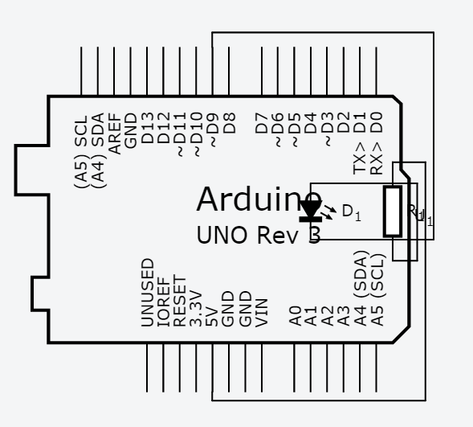
- 修正程式碼
// Pin 13 has an LED connected on most Arduino boards.
// give it a name:
int led = 9;
// the setup routine runs once when you press reset:
void setup() {
// initialize the digital pin as an output.
pinMode(led, OUTPUT);
}

// the loop routine runs over and over again forever:
void loop() {
digitalWrite(led, HIGH); // turn the LED on (HIGH is the voltage level)
delay(500); // wait for a second
digitalWrite(led, LOW); // turn the LED off by making the voltage LOW
delay(2000); // wait for a second
}

